**Ideation Phase**

|  |  |
| --- | --- |
| **Date** | 01/11/2025 |
| Time id | NM2025TMID06951 |
| **Project name** | Laptop Request Catalog Item |
| **Maximum mark** | 5 marks |

**Brainstorm, Idea prioritization**

**Ideation Phase**

The **Ideation Phase** aimed to explore and define innovative solutions to address inefficiencies in the organization’s current laptop request process. The existing system relied heavily on manual communication and email-based approvals, leading to frequent delays, lack of visibility, and administrative burden. To resolve these issues, the team collaborated to generate, evaluate, and prioritize ideas that would streamline the entire request and approval workflow.

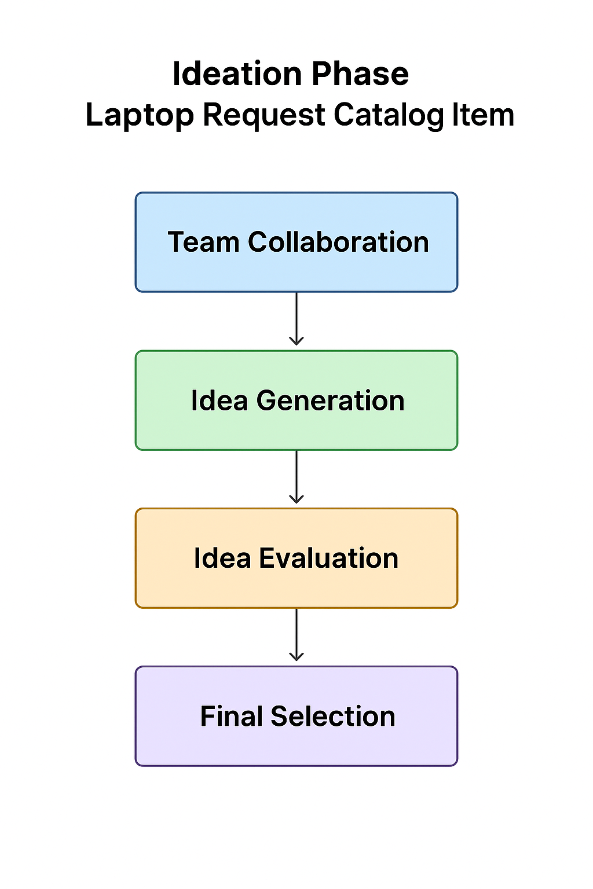

**Step 1: Team Gathering, Collaboration and Select the Problem statement**

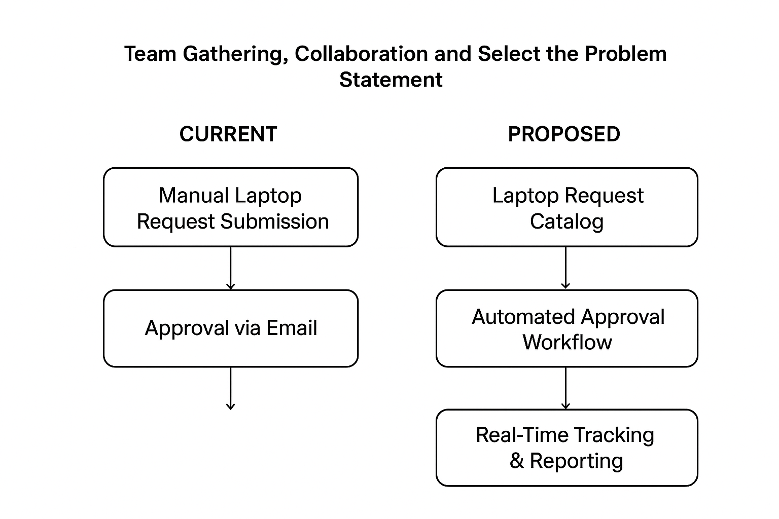

**Step 2: Idea Generation**

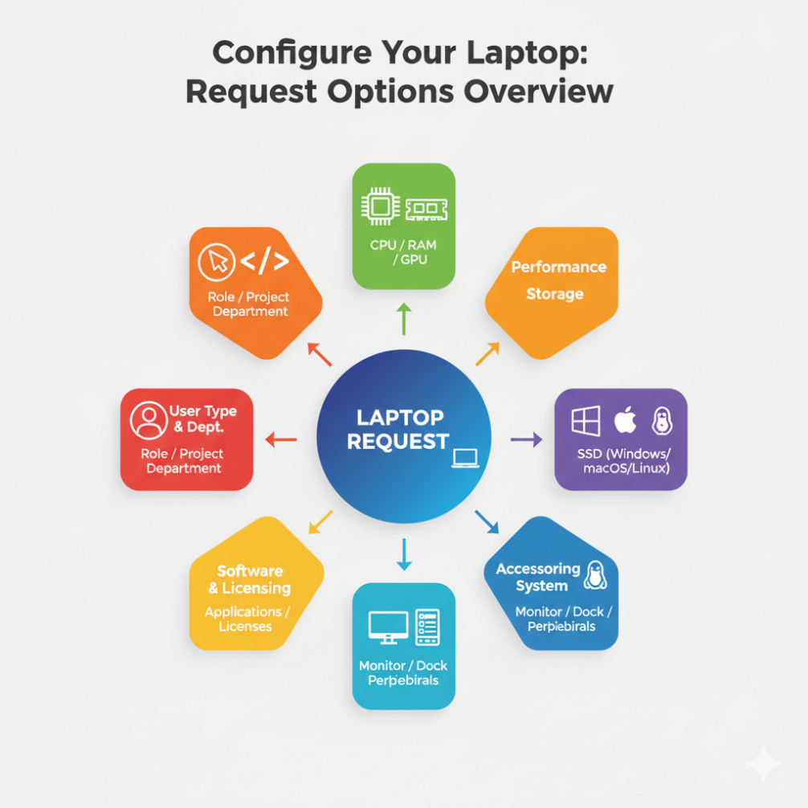

**Step 3: Idea Evaluation**

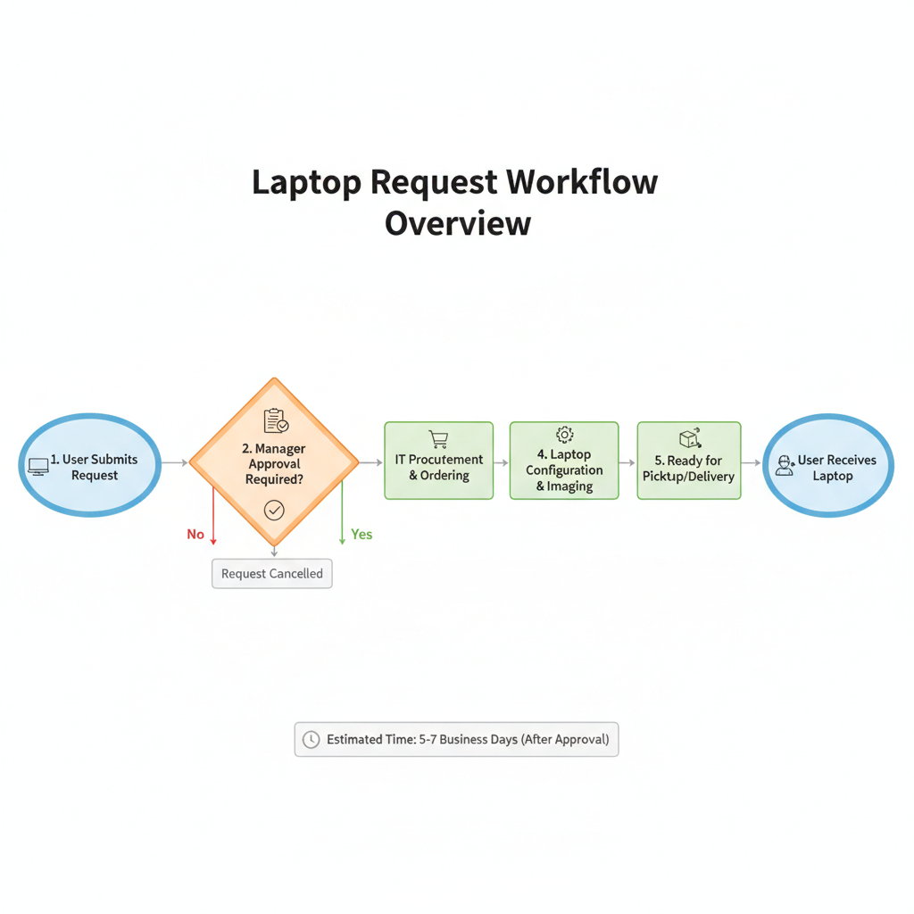**Step 2: Final Selection**

